|  |
| --- |
| OEM / Factory recovery partition creator – 6.0.0 |
| By AnarethoS |
| Friday, November 10 2023 / 2:48 PM |

Table of content

Table of content

1 Important note – Windows 10 and Windows 11 1

2 Warning – End of support 1

3 Introduction 2

3.1 Description 2

3.2 What this software can do 2

3.3 What this software cannot do 2

3.4 Target audience and required skills 3

3.5 Don’t use this software if… 3

4 Features comparison 4

4.1 Windows 1X 4

5 Requirements 5

5.1 Windows 1X 5

6 Installation 6

6.1 Windows 1X 6

6.1.1 Supported configuration 6

6.1.2 USB drive preparation 10

6.1.3 Windows installation 10

6.1.4 Windows customization 10

6.1.5 Installing recovery software 11

6.1.6 Accessing recovery tools 11

6.1.7 Customization 11

6.1.8 Full recovery image versus dynamic recovery image 12

7 Settings file explanation 14

7.1 Windows 1X 14

8 Splash image support 15

9 Upgrading 16

10 Translation 16

11 Step-by-step demonstration – Windows 1X 17

11.1 Configuration used for the demonstration 17

11.2 Installation media preparation 17

11.3 Windows installation 20

11.4 Applications and drivers installation 22

11.5 Recovery tools installation 23

11.6 OOBE execution 25

11.7 Testing recovery from local partition 26

12 ADDON - Password protection 30

12.1 What will be protected 30

12.2 How to install 31

12.3 How to uninstall 31

13 Technical support 32

14 Credits and thanks 32

15 Licensing 33

16 Warranties 34

17 Change log 35

# Important note – Windows 10 and Windows 11

**Starting with version 5.0.1, Windows 11 will now be supported.**

**Due to similarities between Windows 10 and Windows 11, creating a new version for Windows 11 was deemed redundant. As such, both OS will share the same tools and will be referenced as Windows 1X rather that Windows 10 or Windows 11.**

# Warning – End of support

**Windows 7/8/8.1 support was removed starting in version 6.0.0 of this software. If you require the software for theses OS, please use previous versions.**

**Due to the end of life of Windows 7 in January 2020 and the low popularity of Windows 8/8.1, the support for theses OS is now stopped. New development is only for the Windows 1X tools.**

**This software will still include the tools for theses OS versions, but they will not be updated anymore except on really race occasions, like it was with version 5.0.0.**

**This means that no new feature will be added, included tools will not be updated, support will not be provided. Also, if the tools stop working for theses version they may not be fixed.**

**Thanks for your comprehension.**

# Introduction

## Description

The purpose of this software is to help create a factory reset option on a computer running Windows 10/11. A factory reset solution allows the end user to completely reinstall Windows on their personal computer from a hidden recovery partition. During the recovery process the user can decide to keep, or not, their personal files.

This solution is similar to what can be found on brand name computer on the market. Inspired by Microsoft documentation this software adds some functionalities like offline file browsing, registry edition, etc.

Since this software depends on some proprietary files from Microsoft, you will have to download [Windows ADK](https://msdn.microsoft.com/en-us/windows/hardware/dn913721.aspx) (**Windows 1X**).

This software requires particular partition layout and cannot be used on an already installed version of Windows. This software will be incorporated into your installation process (partition creation, audit mode, OOBE, etc.).

## What this software can do

* Reinstall Windows without losing any personal file
* Do a clean installation of Windows, removing all personal files
* Create recovery media (USB or DVD, depending of the OS) that can be used to completely reinstall Windows on a new hard disk on the same computer
* Allows you to access personal files even if Windows is not working by using an offline file browser

## What this software cannot do

* Backup you current Windows installation
* Create recovery partition on an existing Windows installation
* Create a generic recovery media to use on different computer
* Update the factory image (except under Windows 8)

## Target audience and required skills

* This software is intended for computer technician who build computer for their clients or themselves and that want to have an option to revert to a factory image
* This software is not intended for those who don’t have strong computer knowledge
* This software suppose you have basic to medium skill with
  + Windows installation
  + DISKPART
  + CMD scripts
  + DISM
  + SYSPREP
* Also, although not required, knowledge of AUTOIT scripting may be required if you want to edit or change the GUI behavior

## Don’t use this software if…

* You are an end-user without computer skill
* If you still think this software is a backup software
* If you are not able to “read between the lines” and must ask question for everything which is not documented
* If you are not willing to do a lot of test in a virtual environment or on physical system to find the best configuration scenario for your needs

# Features comparison

This section enumerates the different options available per operating system. Available feature in GREEN are not part of the default functionalities of the operating system for the recovery process and are added by this software.

## Windows 1X

|  |  |
| --- | --- |
| **Feature** | **Available** |
| Factory reinstall – Delete all files (Push-Button Reset) | Yes |
| Factory reinstall – Keep personal files (Push-Button Reset) | Yes |
| Factory reinstall – Bare metal recovery from WIM image | Yes |
| Offline file browser | Yes |
| Offline registry editor | Yes |
| USB media creation (Push-Button Reset) | Yes |
| USB media creation (Factory WIM image) | Yes |
| DVD media creation | No |
| Recovery menu with links to different tools + Antivirus and file undelete tools | Yes |
| Image update | No |
| UEFI support | Yes |
| BIOS support | Yes |

# Requirements

## Windows 1X

Build 1703 or newer is required for FULL IMAGE backup since this option requires to be able to create multiple partitions on a USB drive.

From Windows 1X ADK, you will need the following files:

* SCANSTATE files (32 and 64 bits versions)

Sources files for 64 bits version are in the following two (2) folders:

* C:\Program Files (x86)\Windows Kits\10\Assessment and Deployment Kit\User State Migration Tool\amd64
* C:\Program Files (x86)\Windows Kits\10\Assessment and Deployment Kit\Windows Setup\amd64\Sources

Sources files for 32 bits version are in the following two (2) folders:

* C:\Program Files (x86)\Windows Kits\10\Assessment and Deployment Kit\User State Migration Tool\x86
* C:\Program Files (x86)\Windows Kits\10\Assessment and Deployment Kit\Windows Setup\x86\Sources

Copy the 32 bits files to:

* \Windows 1X\Windows 1X Recovery Tools\Recovery\OEM\ScanState\x86

Copy the 64 bits files to:

* \Windows 1X\Windows 1X Recovery Tools\Recovery\OEM\ScanState\amd64

# Installation

## Windows 1X

Compared to Windows 7 and 8, Windows 1X does not have a recovery image on a hidden partition. When reinstalling Windows, a new installation is constructed from the files of the previous one, keeping drivers and some updates. Normally, all applications are deleted. The use of this software allows keeping default application, since they will be saved in a PPKG file which will be reapplied once Windows is reinstalled.

### Supported configuration

**Resizable:** If “YES”, you can edit the script to change the partition size to fit your needs. If “No”, please don’t try to change the specified size without testing first.

**Default:** Default partition layout when installing Windows 1X without any scrip. In this scenario, the recovery tools are on the first partition.

**Recommended:** Based on Microsoft documentation, the recovery partition will be the last of the disk.

**Data partition:** Secondary partition to store your personal files. Easier to backup, but you must be sure of the size of the Windows partition to prevent problems with low disk space.

**Personally, I will recommend you to use the “Default” or “Default with data partition” configuration since you can change the partition after the Windows one without breaking the recovery process since the partition number of the Windows, system and recovery partition won’t change.**

|  |  |  |  |  |  |  |
| --- | --- | --- | --- | --- | --- | --- |
| **Name** | BIOS - Default | | | | | |
| **Installation script path** | \Windows 1X\AutoUnattend\BIOS - Default | | | | | |
| **Settings files path** | \Windows 1X\Windows 1X Recovery Tools\Recovery\OEM\Settings\BIOS - Default | | | | | |
| **Target system** | BIOS / MBR | | | | | |
| **Partition #** | **Size** | **File system** | **Volume name** | **Partition type** | **Role** | **Resizable?** |
| 0 | 1024 Mb | NTFS | Windows RE tools | Primary | Recovery tools | No |
| 1 | 250 Mb | NTFS | System | Active | Boot | No |
| 2 | All | NTFS | Windows | Primary | OS | N/A |

|  |  |  |  |  |  |  |
| --- | --- | --- | --- | --- | --- | --- |
| **Name** | BIOS - Default with data partition | | | | | |
| **Installation script path** | \Windows 1X\AutoUnattend\BIOS - Default with data partition | | | | | |
| **Settings files path** | \Windows 1X\Windows 1X Recovery Tools\Recovery\OEM\Settings\BIOS - Default with data partition | | | | | |
| **Target system** | BIOS / MBR | | | | | |
| **Partition #** | **Size** | **File system** | **Volume name** | **Partition type** | **Role** | **Resizable?** |
| 0 | 1024 Mb | NTFS | Windows RE tools | Primary | Recovery tools | No |
| 1 | 250 Mb | NTFS | System | Active | Boot | No |
| 2 | 60 000 Mb | NTFS | Windows | Primary | OS | Yes |
| 3 | All | NTFS | Data | Primary | Data | N/A |

|  |  |  |  |  |  |  |
| --- | --- | --- | --- | --- | --- | --- |
| **Name** | BIOS - Recommended | | | | | |
| **Installation script path** | \Windows 1X\AutoUnattend\BIOS - Recommended | | | | | |
| **Settings files path** | \Windows 1X\Windows 1X Recovery Tools\Recovery\OEM\Settings\BIOS - Recommended | | | | | |
| **Target system** | BIOS / MBR | | | | | |
| **Partition #** | **Size** | **File system** | **Volume name** | **Partition type** | **Role** | **Resizable?** |
| 0 | 250 Mb | NTFS | System | Active | Boot | No |
| 1 | All | NTFS | Windows | Primary | OS | N/A |
| 2 | 1024 Mb | NTFS | Windows RE tools | Primary | Recovery tools | No |

|  |  |  |  |  |  |  |
| --- | --- | --- | --- | --- | --- | --- |
| **Name** | BIOS - Recommended with data partition | | | | | |
| **Installation script path** | \Windows 1X\AutoUnattend\BIOS - Recommended with data partition | | | | | |
| **Settings files path** | \Windows 1X\Windows 1X Recovery Tools\Recovery\OEM\Settings\BIOS - Recommended with data partition | | | | | |
| **Target system** | BIOS / MBR | | | | | |
| **Partition #** | **Size** | **File system** | **Volume name** | **Partition type** | **Role** | **Resizable?** |
| 0 | 250 Mb | NTFS | System | Active | Boot | No |
| 1 | 60 000 Mb | NTFS | Windows | Primary | OS | Yes |
| 2 | All | NTFS | Data | Primary | Data | N/A |
| 3 | 1024 Mb | NTFS | Windows RE tools | Primary | Recovery tools | No |

|  |  |  |  |  |  |  |
| --- | --- | --- | --- | --- | --- | --- |
| **Name** | UEFI - Default | | | | | |
| **Installation script path** | \Windows 1X\AutoUnattend\UEFI - Default | | | | | |
| **Settings files path** | \Windows 1X\Windows 1X Recovery Tools\Recovery\OEM\Settings\UEFI - Default | | | | | |
| **Target system** | UEFI / GPT | | | | | |
| **Partition #** | **Size** | **File system** | **Volume name** | **Partition type** | **Role** | **Resizable?** |
| 0 | 1024 Mb | NTFS | Windows RE tools | Primary | Recovery tools | No |
| 1 | 250 Mb | FAT32 | System | EFI | Boot | No |
| 2 | 16 Mb | MSR | N/A | MSR | System reserved | No |
| 3 | All | NTFS | Windows | Primary | OS | N/A |

|  |  |  |  |  |  |  |
| --- | --- | --- | --- | --- | --- | --- |
| **Name** | UEFI - Default with data partition | | | | | |
| **Installation script path** | \Windows 1X\AutoUnattend\UEFI - Default with data partition | | | | | |
| **Settings files path** | \Windows 1X\Windows 1X Recovery Tools\Recovery\OEM\Settings\UEFI - Default with data partition | | | | | |
| **Target system** | UEFI / GPT | | | | | |
| **Partition #** | **Size** | **File system** | **Volume name** | **Partition type** | **Role** | **Resizable?** |
| 0 | 1024 Mb | NTFS | Windows RE tools | Primary | Recovery tools | No |
| 1 | 250 Mb | FAT32 | System | EFI | Boot | No |
| 2 | 16 Mb | MSR | N/A | MSR | System reserved | No |
| 3 | 60 000 Mb | NTFS | Windows | Primary | OS | Yes |
| 4 | All | NTFS | Data | Primary | Data | N/A |

|  |  |  |  |  |  |  |
| --- | --- | --- | --- | --- | --- | --- |
| **Name** | UEFI - Recommended | | | | | |
| **Installation script path** | \Windows 1X\AutoUnattend\UEFI - Recommended | | | | | |
| **Settings files path** | \Windows 1X\Windows 1X Recovery Tools\Recovery\OEM\Settings\UEFI - Recommended | | | | | |
| **Target system** | UEFI / GPT | | | | | |
| **Partition #** | **Size** | **File system** | **Volume name** | **Partition type** | **Role** | **Resizable?** |
| 0 | 250 Mb | FAT32 | System | EFI | Boot | No |
| 1 | 16 Mb | MSR | N/A | MSR | System reserved | No |
| 2 | All | NTFS | Windows | Primary | OS | N/A |
| 3 | 1024 Mb | NTFS | Windows RE tools | Primary | Recovery tools | No |

|  |  |  |  |  |  |  |
| --- | --- | --- | --- | --- | --- | --- |
| **Name** | UEFI - Recommended with data partition | | | | | |
| **Installation script path** | \Windows 1X\AutoUnattend\UEFI - Recommended with data partition | | | | | |
| **Settings files path** | \Windows 1X\Windows 1X Recovery Tools\Recovery\OEM\Settings\UEFI - Recommended with data partition | | | | | |
| **Target system** | UEFI / GPT | | | | | |
| **Partition #** | **Size** | **File system** | **Volume name** | **Partition type** | **Role** | **Resizable?** |
| 0 | 250 Mb | FAT32 | System | EFI | Boot | No |
| 1 | 16 Mb | MSR | N/A | MSR | System reserved | No |
| 2 | 60 000 Mb | NTFS | Windows | Primary | OS | Yes |
| 3 | All | NTFS | Data | Primary | Data | N/A |
| 4 | 1024 Mb | NTFS | Windows RE tools | Primary | Recovery tools | No |

**New since version 4.2.2:** You can now install Windows 1X on a different drive than the drive 0. This is sometime required with computer with both NVMe and SATA disk since the NVMe disk will sometime be the disk 1 or 2.

In that case, use the file from the corresponding folder under the path:  
“\Windows 1X\AutoUnattend\$Install on Drive X$”

### USB drive preparation

* Format an USB drive using FAT32
* Make the device bootable using DISKPART, Disk Manager or other way
* Copy the whole installation disc on the USB drive
* From the “Installation script path” identified in the previous step, copy the AutoUnattend.xml file or the DISKPART script (TXT file) to the ROOT of the drive
* From the “\Add-On\Ei.Cfg” folder, copy the “Ei.cfg” file to the SOURCES folder of the USB drive
* Copy the whole recovery software (the whole package) on the USB drive in a new folder of your choice
* The device is now ready to be used on the target computer

### Windows installation

* Connect the USB drive on the target computer and boot the computer from the drive
* If you are using an AutoUnattend.xml file, simply start the Windows installation but if you are using a DISKPART script, do the following
  + Press SHIFT+F10 to open a command prompt
  + Type “DISKPART /S D:\ScriptName.txt”
    - Where D is the letter of the USB drive
    - Where ScriptName.txt is the name of the DISKPART script copied from the “Installation script path”
  + Install Windows on the WINDOWS partition
* If using an AutoUnattend.xml file, the computer will boot in AUDIT mode but if you are using a DISKPART script, do the following
  + On the final boot, where you are asked to configure the computer (OOBE), press CTRL+SHIFT+F3 to reboot in AUDIT mode
* Now Windows is installed, in AUDIT mode and ready to be adapted to your needs.

### Windows customization

* You can now install all Windows software, drivers and updates you want in the final factory image
* When your installation is complete, disconnect the computer from the network and reboot a last time to be sure no Windows update are pending, etc.

### Installing recovery software

* Run the “Install – Windows 1X.cmd” script from “\Windows 1X\Windows 1X Recovery Tools”
* If you want to execute some scripts or command AFTER the OOBE process, edit the “C:\Recovery\OEM\Scripts\OOBE-Custom.cmd” file
* From “C:\Recovery\OEM\Settings\<Desired configuration>”, copy the “ResetConfig.xml” and “ReCreatePartitions.txt” files to “C:\Recovery\OEM”
  + <Desired configuration> must match the one used to install Windows on the computer, if the partition number mismatch you will have to restart from the beginning!
* From “C:\Recovery\OEM” run the “Sysprep.cmd” script
  + The computer will mask the updates as permanent
  + All software will be saved in a PPKG file under “C:\Recovery\Customizations”
  + Sysprep will be run and the computer will shut down automatically
  + You will be asked to chose between two kind of recovery mode which are “Full image” and “Push-Button Reset”. Click here to find more about the differences.

### Accessing recovery tools

* Boot the computer in the Windows Recovery Environment by holding the SHIFT key when clicking in “Reboot” in Windows
* By rebooting three time in a row Windows during the boot process
* Using the “Recovery Tools” icon in the start menu

### Customization

Partition layout can be modified to suit your needs. To do so, edit the “AutoUnatted.xml”, “ReCreatePartitions.txt” and “ResetConfig.xml” file to make your change.

When using “AutoUnattend.xml” file, only the LAST partition can be of dynamic size. If this is not the case, you will have to create a DISKPART script to use during the Windows installation step to configure your partitions layout.

After the execution of the OOBE step, the “C:\Recovery\OEM\Scripts\OOBE-Custom.cmd” file will be executed. You can use this file to install application, drivers or to make change to the computer. If you need to keep installation files between recovery processes, put them in any folder under “C:\Recovery\OEM”. These files are kept and are copied on the recovery USB media.

### Full recovery image versus dynamic recovery image

Since version 4.1.0 the system integrator can choose between a full image capture and a dynamic image also known as “Push-Button reset” image.

#### Dynamic recovery image / Push-Button reset

Starting with Windows 1X, there is a new recovery option, called “Push-Button reset” which offer the ability to recover Windows without using a recovery image. This method rebuilds the new Windows installation from the current installation, keeping all drivers, updates and build. You also have the option to keep your personal files or delete everything.

It is also possible to create a recovery media with this custom image for the computer.

When reinstalling from the local hard-drive, all the current patches, drivers and updates are kept. When using the recovery media, all patches, drivers and build present on the computer at the creation time are kept. When using the recovery media, you cannot keep your files.

There is currently a bug on some computer depending of the Windows media used. On theses computer, media created after a local recovery are not working. But, if the media is created before attempting a local recovery, the media will work. To prevent this, a “Full image” option has been added (see next point).

* Advantages of Push-Button reset image
  + Keep all drivers of currently installed hardware (great when doing upgrades)
  + Keep patches that are older than 30 days
  + Takes less space on the hard-disk
* Drawbacks of Push-Button reset image
  + In case of a big corruption of Windows, it may not work
    - Starting with Windows 1X 2004, the “Restore from Cloud” should fix the data corruption of Windows
  + Cannot go back to a previous build after an upgrade

#### Full recovery image

The “Full image” option keep an image file on the Windows partition that allows the end-user to create a recovery media for bare-metal recovery.

This media will completely “wipe-out” the hard-disk and reinstall Windows with the original image with all the patches, drivers and build that where present on the computer at the build time.

When doing a local recovery (from local disk, not from USB drive), the “Push-Button Reset” image will be used, keeping all patches, drivers and build from the current version of Windows.

This option takes more space on the computer so is not recommended for small hard-disk.

It’S main advantage is that the recovery image will allows you to go back to the original build of Windows. Also, the known bug with the recovery image creation after a local recovery is not present with this method.

* Advantages of full recovery image
  + Original image with all applications, drivers and patches
  + Works across reinstallation
  + “Push-Button reset” still available with all it’s advantage for local recovery
* Drawbacks of full recovery image
  + Takes more space on the hard-disk

Please note that the “Full image” can be deleted from the computer using a script. Doing this will convert the current installation from “Full image” to “Push-button reset”.

To do so, execute the following script:

* “C:\Recovery\OEM\Scripts\DeleteImage.cmd”

If space is an issue, I would recommend to do a “Full image” capture, create the recovery media, delete the image and then do a local reset so a full image will be available on the media while the “Push-button reset” option will be available locally on the computer.

The “Full Image” option is only available on build 1703 and later of Windows 1X.

# Settings file explanation

This software requires lots of settings files to work correctly. You must be very careful if you do any modification to them.

Don’t touches any files except the one identified here, otherwise the whole capture/restore process may not work.

## Windows 1X

* Settings.ini
  + This is the file that include all language strings for the recovery tools
* RecreatePartitions.txt
  + This is the script used by the recovery media (USB) to repartition the hard disk
  + It must match the settings of the “ResetConfig.xml” and “AutoUnattend.Xml” file
  + Must NOT include “Select Disk” or “Clean” commands
* ResetConfig.xml
  + Used to tell recovery image location (partition number, etc.) in the recovery environment
  + Used to tell the name of the “RecreatePartitions.txt” file
  + Used to tell the name of the recovery script “Restore.cmd” file
  + It must match the settings of the “ResetPartitions.txt” and “AutoUnattend.Xml” file
* Unattend.xml
  + File used to prepare Windows for capture
  + Used to keep drivers and not delete them
* WinRE.xml
  + Used to rename the DoubleCommander file browser to “Off-Line file browser”
* OOBE-Custom.cmd
  + Used to execute custom script after the OOBE state
  + Please put the files you need to execute under “C:\Recovery\OEM”

# Splash image support

Starting in version 1.3.10, there is now a splash image for the recovery tools inside Windows. This splash image does not apply to the recovery tools when booting on the recovery media or the recovery partition.

* The image must be placed in the following folder for Windows 1X
  + “Windows 1X Recovery Tools\Recovery\OEM\Menu”

Once the file copied, you must edit “Settings.ini” file to enable it and change the following parameters:

|  |  |  |
| --- | --- | --- |
| **Parameter** | **Description** | **Default Value** |
| LogoFile | Filename of the logo. Must be JPG or BMP. | Logo.jpg |
| LogoWidth | Width of the logo | 400 |
| LogoHeight | Height of the logo | 200 |
| LogoTime | Time, in seconds, to display the logo. | 0 |

# Upgrading

Upgrade script is available for Windows 1X tools. It will also update the full image if one was created.

It is recommended to create a new recovery media once the tools are upgraded.

The upgrade process keep the “OOBE-Custom” file so custom script will continue to run on restore. All custom files added in others directory not made by this tool will also be kept. If, by example, you created a “Drivers” or “Apps” folder under the “OEM” folder, they will be kept between upgrades.

# Translation

Edit the SETTINGS.INI file in one of the following paths to adapt the software to your language.

* Windows 1X
  + “\Windows 1X\Windows 1X Recovery Tools\Recovery\OEM\Menu”

Simply copy/paste the [0409] section in a new one and change the language code of the new section to match the real code of the new language. Add the new language code in the “LanguageList” item under the [General] section.

Semi-colons (;) can be used as a carriage return to skip a line.

No translation support for Windows 8.1 – WIM boot

# Step-by-step demonstration – Windows 1X

## Configuration used for the demonstration

For this demonstration, a virtual computer will be used using the following configuration:

* + VmWare Workstation for the hyper-visor
  + 120gb virtual disk
  + 2gb of ram
  + UEFI / GPT mode (required for booting on USB media)

Also, the following partitions layout will be used:

* + UEFI - Default with data partition

This layout includes an “AutoUnattend.xml” file, so no manual execution of DISKPART will be required.

## Installation media preparation

Although some software exist on the Internet do make a USB installation media, I prefer to use DISKPART to prepare the USB drive.

Fist, find the actual letter of the drive.



Then, open DISKPART and type the following command to format the drive and make it bootable. Replace “F” by the letter actually assigned to you USB media.

|  |
| --- |
| SELECT VOLUME F  CLEAN  CREATE PARTITION PRIMARY  FORMAT FS=FAT32 QUICK LABEL=WININST  ACTIVE  ASSIGN LETTER F |

Now, simply copy the Windows 1X installation media on the USB media.

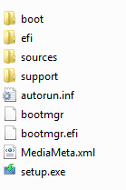

Copy the recovery tools installation folder on the USB media.



Copy the “AutoUnattend.xml” file in the root of the USB media.



Copy the “EI.CFG” file to the” Sources” folder on the USB media.



At the end, the root of the USB media should look like that.

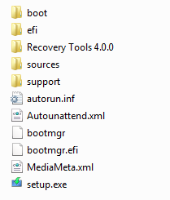

Now, we must add the “ScanState” file in the following folders:

|  |
| --- |
| F:\Recovery Tools 4.0.0\Windows 1X\Windows 1X Recovery Tools\Recovery\OEM\ScanState\amd64 |
| F:\Recovery Tools 4.0.0\Windows 1X\Windows 1X Recovery Tools\Recovery\OEM\ScanState\x86 |

Both folders should look likes that:

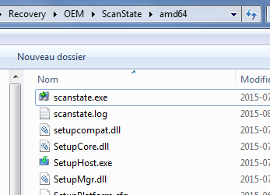

From now, the following step must be done in the virtual machine / target computer!

## Windows installation

Start the computer and let it boot from the USB media.



Since we are using an AutoUnattend.xml file, the Windows setup will automatically start.



Select you keyboard and language settings.

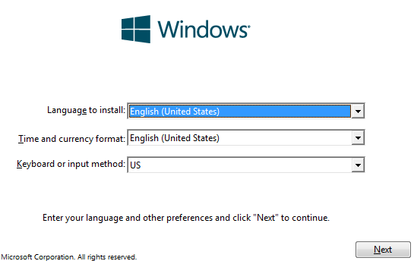

Wait for the Windows installation to complete.

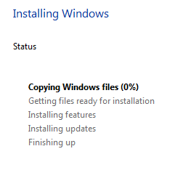

Once Windows installed, you should see that on the last reboot.

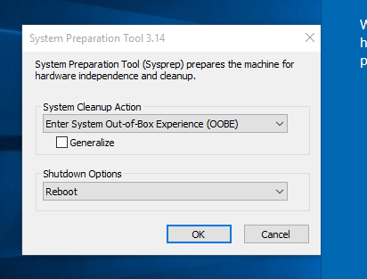

## Applications and drivers installation

Since we are installing Windows under VmWare, we will install the VmWare tools and some test application using Ninite.

We will install WinRar, FireFox and Notepad++.

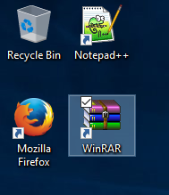

We also installed the available updates.

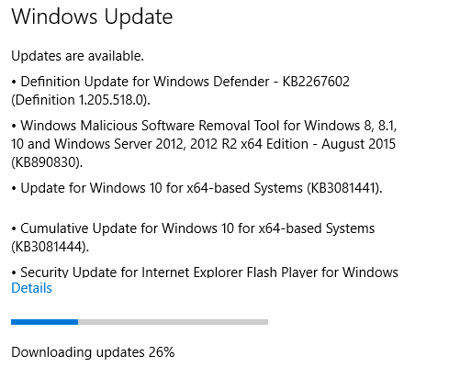

Once the updates installed, disconnect the computer from the network and reboot before continuing to the next step.

## Recovery tools installation

Now, we must go on the USB installation media in the “Windows 1X Recovery Tools” folder



And execute the “Install – Windows 1X.cmd” script.



This will copy the tools to “C:\Recovery”. Once completed, the USB installation media can be removed.

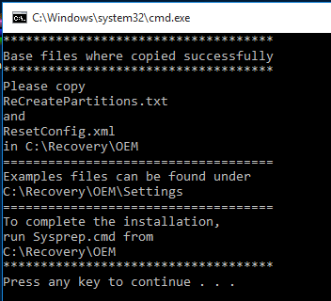

Now, from “C:\Recovery\OEM\Settings\UEFI - Default with data partition”, copy all the files to “C:\Recovery\OEM”.

Adapt the source files depending of your current partition layout.

Now, from “C:\Recovery\OEM” execute the “Sysprep.cmd” script.

This will capture all the drivers, applications, settings, etc. and then shut down the computer.

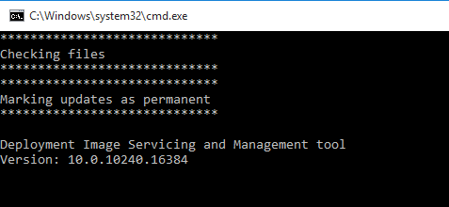

The recovery image is now ready.

## OOBE execution

On the next boot, the computer will go through the regular OOBE process, where you can create a new user.

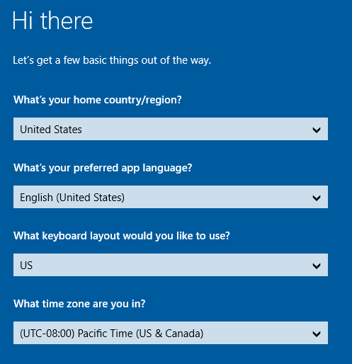

Here a new user name “TestUser” was created.



Now the computer is ready to use.

## Testing recovery from local partition

We will now test the recovery process.

First, we must launch the recovery tool from the start menu.

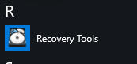

Now, we will select the “I want to repair my computer” option and confirm to reboot.

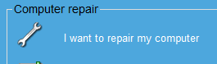

The recovery environment will start on the next boot.

We will select the “Troubleshoot” option.

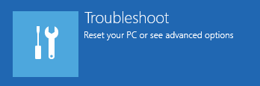

From there we can select the “Advanced tools” which includes the **registry editor, the file browser, etc.** But to restore the computer, it is the “Reset this PC” option that we need.

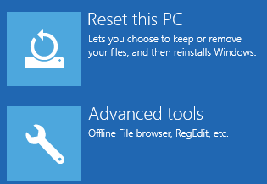

We will select the “Remove everything” option to completely clean the computer.

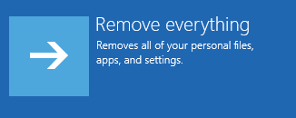

Since we have multiple partitions, we will select to clean only the Windows partition by clicking on “Only the drive where Windows is installed”.



Finally, we will select the option “Just remove my files” which delete everything but without completely formatting the disk first. It is faster.



Now we must confirm one last time by clicking on “Reset”.

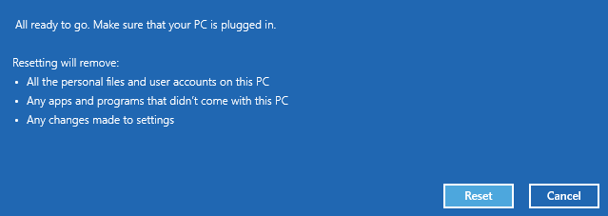

We must then wait for Windows to be reinstalled.

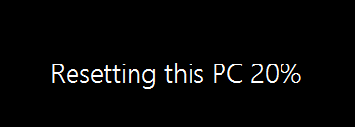

We have to wait again …

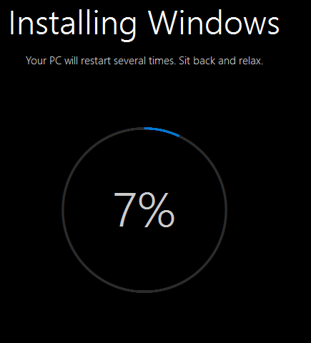

Once reinstalled, Windows will go through the OOBE process as usual.

We will create a new user. This time, we will call it “TestUser-#2”.



We can see that all applications are still there.

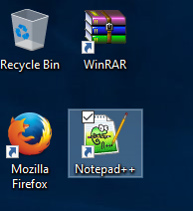

Even the Windows updates are still present.

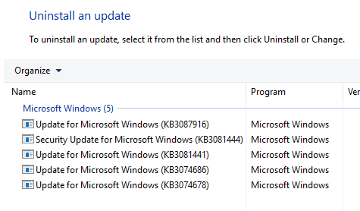

# ADDON - Password protection

## What will be protected

Access to the recovery tools are protected under Windows 7. The password of a local account is required to access the recovery tools and, by extension, the file manager that this software add to it.

Starting with Windows 8, a password is no more required to access the recovery tools. With the fact that the recovery tools include a file browser, this pose a security risk.

So, starting with version 4.0.0, a new password was added, which is optional and that can be installed at any time.

This password will protect the following

* Windows 1X
  + Recovery tools from the hard disk drive
  + Recovery tools from USB drive if created AFTER the password was added

## How to install

To install it, simply run the “Install Password.cmd” script from “\Add-On\WinRE Password”. During the installation process, the following window will open.

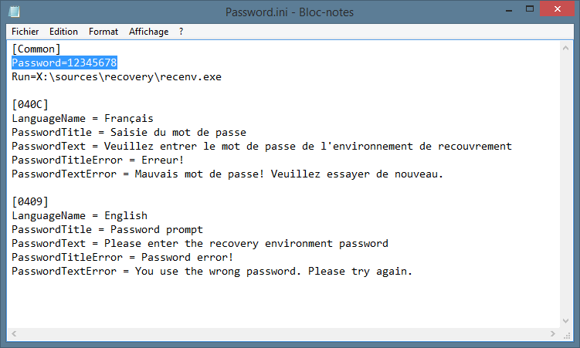

Simply put the desired password in the file, save and exit. The password will be required each time you will enter the recovery tools.

## How to uninstall

Uninstalling doesn’t require knowing the previous password, so uninstalling can be used to remove the tool completely or in case the password is forgotten.

To remove, simply run the “Remove Password.cmd” file from “\Add-On\WinRE Password”.

# Technical support

[Technical support is provided free of charge on the “My Digital Life” forums.](https://forums.mydigitallife.net/threads/oem-recovery-partition-creator-for-windows.21978/)

[Update to this software can be found on my personal web page.](http://www.anarethos.com)

# Credits and thanks

Thanks to the “My Digital Life” forums community. Without you guys, this software won’t have been made possible.

Also, thanks to my entire beta tester.

# Licensing

* All scripts, either the one made for command line (CMD) or in AutoIT, where made by me, Anarethos. These files can be freely distributed and modified. Just give me credits.
* The file browser (DoubleCommander) included with this software is a SourceForge project and more info can be found by [clicking here](http://doublecmd.sourceforge.net/).
* The Hard Drive icon used in the software was found on Internet. Source unknown. If you are the owner of this icon, please contact me (support forum) so I may remove it from this software or gives you credits for your works.
* Windows 1X icons are from [Material Desing](https://material.io/) and can be found under the “Sources” folder. They are free to use.
* KickassUndelete (file undelete tools) is an open source project that can be found [here](http://kickassundelete.sourceforge.net/).
* ClamWin (antivirus) is an open source antivirus. The full software can be found [here](http://www.clamwin.com/) and the portable version used in this tool can be found [here](https://portableapps.com/apps/security/clamwin_portable).
* [AutoIT](https://www.autoitscript.com) is made by Jonathan Bennett and the AutoIT group. All files are in the “Source” folder.
* If you are a computer manufacturer/store/seller, you can use my tool without any compensation (free laptop may be cool though!). But, I would really appreciate if you can send me a message telling me that you are using my software. Also, please give me credits on your web site or instruction manual.

# Warranties

* This product is given as-is without any warranty that it will works for you
* Neither the creator of this software or the system integrator that installed it on your computer can be found responsible for:
  + Data lost by using this software
  + Lost of productivity by using this software
  + Any legal complication due to the use of external material
  + Basically, they cannot be responsible of anything 😊
* All external software/tools/EXE/Etc. use by this software are the propriety of their respective owner and you are expected to understand and respect their End-Used License Agreement.
* This software is made in Montréal, Québec, Canada. The files are hosted in Canada.
* This software is free. If you paid for it, you have been scammed
  + Still, your system manufacturer may have charged you for the time needed to create a recovery partition. The creator of this software did not get anything from that. Any complain should be made to your system manufacturer.

# Change log

* 6.0.0
  + Added: Support for Windows 11 23H2
  + Removed: Windows 7/8/8.1 support
  + Changed: Default size of the WindowsRE partition
  + Updated: DoubleCommander, ClamWinAV, AutoIT
* 5.0.5
  + Windows 1X : Support for 22H2 and update to ClamAV and DoubleCmd
* 5.0.4
  + Windows 1X: Option to skip the “Generalize” option with Sysprep
  + Windows 1X: Language detection fix for the gui
* 5.0.3
  + Windows 1X: Support for installing APPX/MSIX after OOBE
* 5.0.2
  + Fixed: Default partition size for USB Recovery in Windows 1X since Windows 11 take more space
* 5.0.1
  + Added: Support for Windows 11
  + Added: Support for Windows 10 21H1
  + Added: Option to inject Appx apps in Windows 1X
  + Updated: Boot files for recovery media in Windows 1X
  + Changed: Windows 10 and Windows 11 are referenced as Windows 1X
* 5.0.0
  + Changed: Nearly all AutoIT script are now interpreted and not compiled which will prevent a lots of false positive
    - Only one file remains for Windows 7 but it will be hidden in the WinRE.wim file and not detected once installed
  + Added: The installation package is now password protected to prevent it from being detected as a virus due to the presence of the last file required for Windows 7
  + Added: Splash image for all version of the tools
  + Added: A built-in script to prevent the computer from going to sleep mode while creating USB/DVD image which could corrupt data
  + Fixed: The “DeleteImage” file for Windows 1X does not ask confirmation for each file anymore
  + Removed: “AppsUpdate.cmd” script for Windows 1X
  + Removed: ScanState files are now removed from Windows 1X once the computer is ready for the client
* 4.2.2
  + Added: Support for Windows 1X 20H2
  + Added: Windows 1X can now be installed on DISK 1 or DISK 2
  + Added: Bare metal recovery (WIM) for Windows 1X let you choose destination drive
  + Added: All files are now signed with a self-signed certificate that is automatically installed during the OOBE process in Windows 1X
  + Fixed: Some text in French for Windows 1X
* 4.2.1
  + Added: Support for Windows 1X 2004
  + Updated: Boot files (USB Media) for Windows 1X
  + Updated: DoubleCommander for Windows 1X
  + Fixed: Recovery creator works with more than 10 devices connected4.2.0
  + Added: Option to inject drivers into the recovery environment of Windows 1X
  + Added: Support for Windows 1X 1903
  + Added: Antivirus and undelete tools in Windows 1X recovery menu
  + Added: Enabling system restore in Windows 1X on first boot
  + Fixed: French in Windows 1X
  + Fixed: Error #4 when creating recovery media in Windows 1X
  + Removed: Italian for Windows 1X due to new menu
  + Changed: Icons for Windows 1X recovery menu
* 4.1.1
  + Fixed: Bug when really big files where present on the hard drive making SWM file too big to fit on a FAT32 drive making “Full Image” option of Windows 1X unusable. The fix now uses multiple partition on the USB media.
  + Changed: Default partition size for the boot partition and the WinRE partition for Windows 1X.
  + Changed: Way to detect architecture to create icons on the computer in Windows 1X.
  + Added: Administrator account enabled in audit mode when using autounattend.xml file for Windows 1X.
  + Fixed: English translation in Windows 1X.
* 4.1.0
  + Added: Option to create a full recovery image under Windows 1X
  + Fixed: Auto download disabled in Windows 1X when using Autounattend.xml
  + Changed: Default WinRE partition size in Windows 1X
  + Removed: File signature on script due to end of life of the CA (StartCom)
* 4.0.8
  + Fixed: Windows 1X compatibility with build 16299
  + Fixed: Windows 1X update script (unsupported option)
  + Fixed: Double execution of logon script under Windows 8/8.1
  + Added: Spanish for Windows 7
  + Added: Windows 1X tools update
* 4.0.7
  + Fixed: Windows 1X compatibility with build 15063
  + Added: Italian language. Thanks to Mathias Carrera
  + Removed: FART tool
* 4.0.6
  + Fixed: English text in Windows 1X tools
  + Changed: EXE files signature
* 4.0.5
  + Fixed: Missing files detection in Windows 1X installer
  + Fixed: Recovery folder protection under Windows 1X
  + Changed: WinRE update screen is now minimized during Windows 1X OOBE
* 4.0.4
  + Fixed: Write protection to “C:\Recovery” under Windows 1X
* 4.0.3
  + Fixed: Capture failure on some computer due to Windows Defender under Windows 1X
  + Changed: Computer reboot when cancelling the password prompt in the recovery environment
* 4.0.2
  + Added: French support for new Canada language pack (0C0C)
  + Changed: Recompiled EXE files to prevent false positive
* 4.0.1
  + Removed: Files that can’t be distributed
* 4.0.0
  + Added: Windows 1X support
  + Added: Password protection
  + Updated: DoubleCMD version
  + Fixed: Better identification of file browser in Windows 8.1 – WIM boot
  + Changed: Whole documentation (this file)
  + Changed: All AutoIT file where recompiled
  + Changed: Folder structure
  + Changed: Default certificate when signing programs
  + Changed: Version identification 🡪X.Y.Z
    - X = Major version, changed when adding new operating system
    - Y = Minor version, changed when adding feature
    - Z = Revision, changed when fixing bug
* 3.0.0-Alpha 3
  + Added: WIM Boot support (Windows 8.1 Update)
* 3.0.0-Alpha 2
  + Changed: Recompiled EXE files to prevent false positive
* 3.0.0-Alpha 1
  + Added: DVD Media Creator for Windows 8 and Windows 7
  + Added: Windows 8.1 support
  + Added: Recovery Image on second partition for Windows 8
  + Removed: All language except French/English for Windows 8 and Windows 7 due to new menu made for DVD recovery
  + Removed: WIM on first partition for Windows 8
  + Removed: OscdImg.exe file which should not be distributed
  + Changed: Version numbering to stop confusion between “current” tools and “Legacy” tools
* 1.3.15
  + Added: UEFI support under Windows 8 32bits (still not supported under Windows 7 32bits)
* 1.3.14
  + Added: Italian under Windows 7 Recovery Tools
  + Added: New version for Windows 8 where recovery image is on the last partition of the computer, allowing the user to delete it after the creation of a recovery USB key
  + Updated: Instruction manual
* 1.3.13
  + Modification to capture and reinstallation script to prevent “phantom” recovery drive under Windows
  + Added: Full system recovery option in Recovery Environment under Windows 7
  + Added: Access to basic repair tools in Recovery Environment under Windows 7
* 1.3.12
  + Windows 8: Now using a FirstLogon script since SetupComplete was not working with OEM key. The script is configured to run by using the Sysprep.xml file.
  + Minor translation error in English fixed
* 1.3.11
  + Fixed bug with the path of the splash screen image
  + Fixed bug in Windows 7 recovery. Not more variable errors.
* 1.3.10
  + Added line-splitting in settings.ini. See translation section
  + Added auto-reboot at the end of the recovery process for Windows 7
  + Added support for splash image under Windows (not recovery media)
* 1.3.9
  + Added: Spanish, Hebrew and Arabic in Windows 7 tools
  + Added: Hebrew in Windows 8 tools
  + Modified recovery media creator script under Windows 7 to make the boot drive “Active”.
* 1.3.8
  + Fixed a bug in the “Update” script relating to SetupComplete script
    - Updates from 1.3.X to 1.3.7 will lose the ability to rename the off-line file browser in Windows 8
    - Updates from 1.3.X to 1.3.7 will lose the ability to dismount automatically the recovery partition in Windows 7 / 8
    - Clean install of 1.3.7 will not have the problem
    - Updating to 1.3.8 should fix that
* 1.3.7
  + Added a script (both in Windows 7 and Windows 8) to dismount the recovery partition from Windows at the end of OOBE
* 1.3.6
  + Added update tools for Windows 7 and 8
    - You can upgrade from 1.2.0 and 1.3.X
    - You must recreate the recovery media after upgrade
    - You must configure the settings file to match your configuration
* 1.3.5
  + Removed ImageX from the package, as required by Microsoft© EULA
  + New set of icons for the menus, which are not made by Microsoft©
* 1.3.4
  + Fixed a bug with the “SetupComplete.Cmd” script under Windows 8 to identify the File Browser
  + Updated the file browser to latest version
  + Added instruction guide (this guide)
* 1.3.3
  + Fixed Windows 8 recovery media. No more error about missing partitions
* 1.3.2
  + Modified installation script so Recovery partition is now hidden in Windows 7
* 1.3.1
  + Added some checkups (Winre.Wim file exist, etc.)
* 1.3.0
  + Initial release of this version which include Windows 8 support